**PROJECT-2**

1. **Which state has the highest number of hotels? Depict this via a bar graph that compares all states.**

As the bar graph suggests, **Kerela** has the highest no of Hotels.

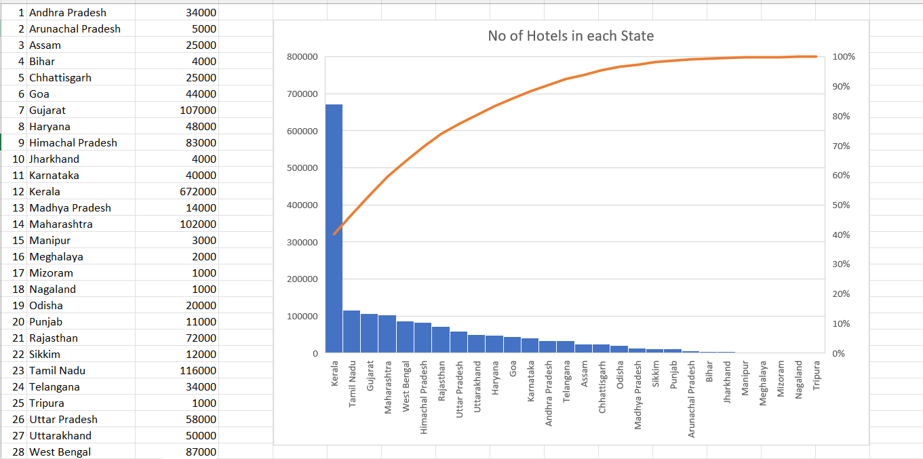

1. **Which states have three types of climatic conditions? (convert the map, an unstructured data, to an Excel file in a structured format and mention the number of climates along with the state)**

|  |  |  |  |  |
| --- | --- | --- | --- | --- |
| **States** | **No of Climate** | **Climate Type 1** | **Climate Type 2** | **Climate Type 3** |
| Andhra Pradesh | 2 | Arid | Tropical Savanah |  |
| Arunachal Pradesh | 2 | Montane Climate | Humid Subtropical |  |
| Assam | 1 | Humid Subtropical |  |  |
| Bihar | 1 | Humid Subtropical |  |  |
| Chhattisgarh | 2 | Humid Subtropical | Tropical Savanah |  |
| Goa | 1 | Tropical Monsoon |  |  |
| Gujarat | 2 | Hot Deserts | Arid |  |
| Haryana | 2 | Hot Deserts | Arid |  |
| Himachal Pradesh | 2 | Arid | Monsoon |  |
| Jharkhand | 2 | Humid Subtropical | Tropical Savanah |  |
| Karnataka | 2 | Tropical Monsoon | Tropical Savanah |  |
| Kerala | 1 | Tropical Monsoon |  |  |
| Madhya Pradesh | 2 | Humid Subtropical | Tropical Savanah |  |
| Maharashtra | 3 | Humid Subtropical | Tropical Savanah | Arid |
| Manipur | 1 | Humid Subtropical |  |  |
| Meghalaya | 1 | Humid Subtropical |  |  |
| Mizoram | 1 | Humid Subtropical |  |  |
| Nagaland | 1 | Humid Subtropical |  |  |
| Odisha | 2 | Humid Subtropical | Tropical Savanah |  |
| Punjab | 1 | Arid |  |  |
| Rajasthan | 2 | Arid | Hot Dessert |  |
| Sikkim | 2 | Montane Climate | Humid Subtropical |  |
| Tamil Nadu | 2 | Arid | Tropical Savanah |  |
| Telangana | 2 | Arid | Tropical Savanah |  |
| Tripura | 1 | Humid Subtropical |  |  |
| Uttar Pradesh | 2 | Arid | Humid Subtropical |  |
| Uttarakhand | 2 | Montane Climate | Humid Subtropical |  |
| West Bengal | 2 | Tropical Savanha | Humid Subtropical |  |

As stated by the graph clearly, **Maharashtra** is the only state that has three climates namely Humid Subtropical, Tropical Savanah, Arid.

1. **Among the northeastern states which are best to set up a hotel? Use Clustered Column Chart and give recommendations for hotel industry investors**

Amongst the seven sisters, six of them have single temperature that is Humid subtropical. Whereas Arunachal Pradesh shares two climates, Humid Subtropical and Montane Climate. 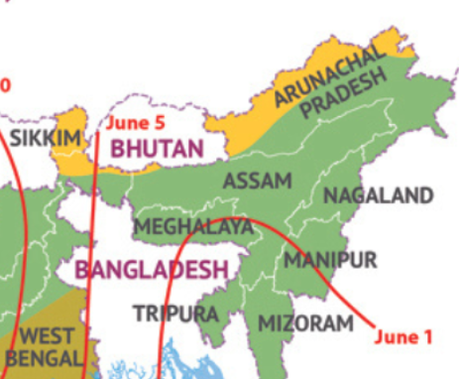

**Factors to consider…**

* **No of Tourist Visits**

1. Assam - 8,382,000

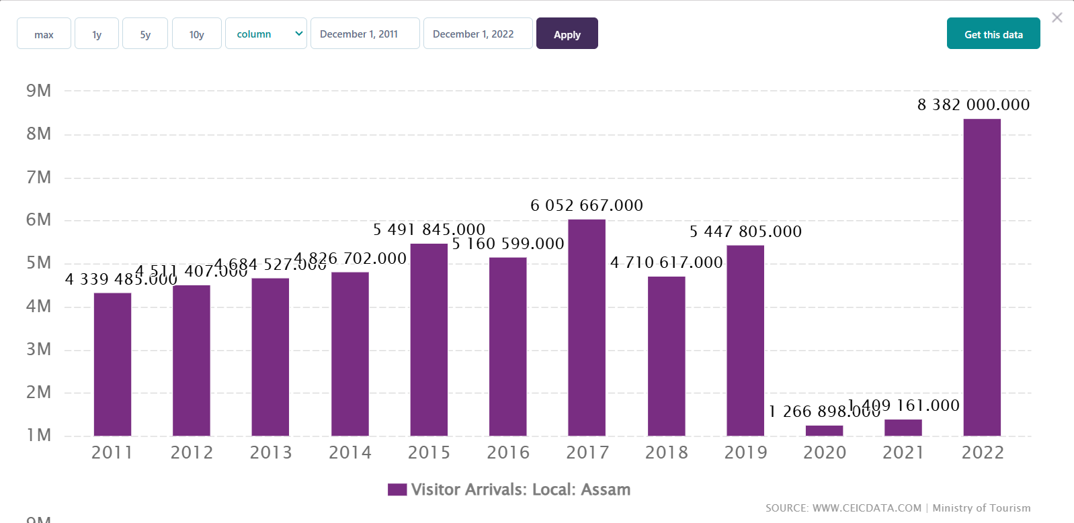

1. Meghalaya 937,100

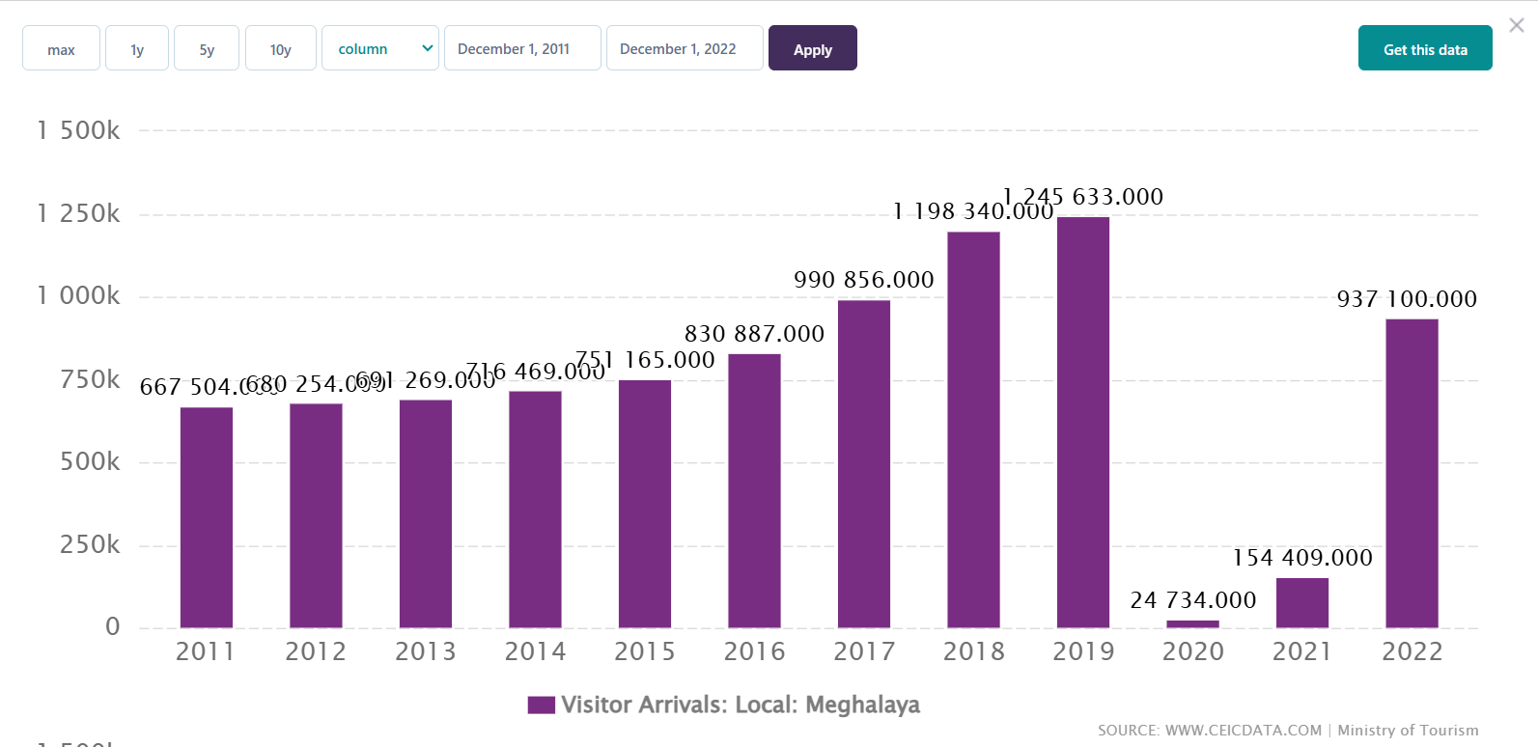

1. Tripura 235,000

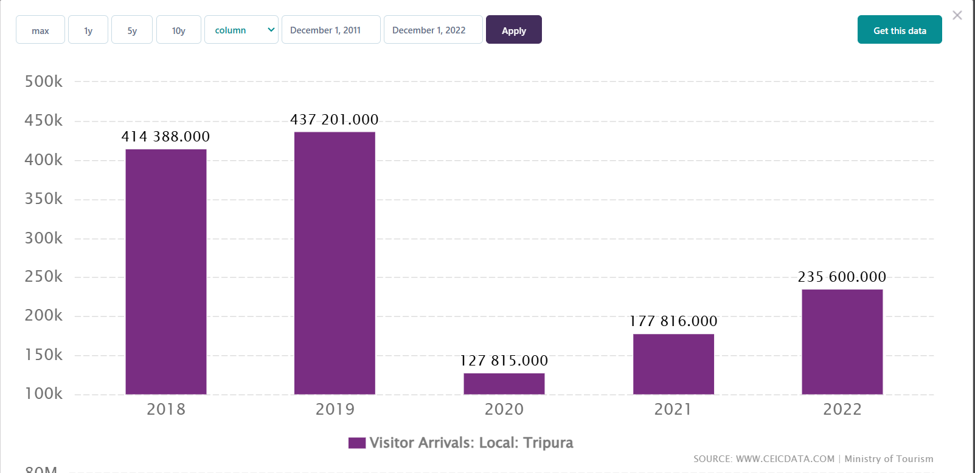

1. Arunachal Pradesh – 222,400

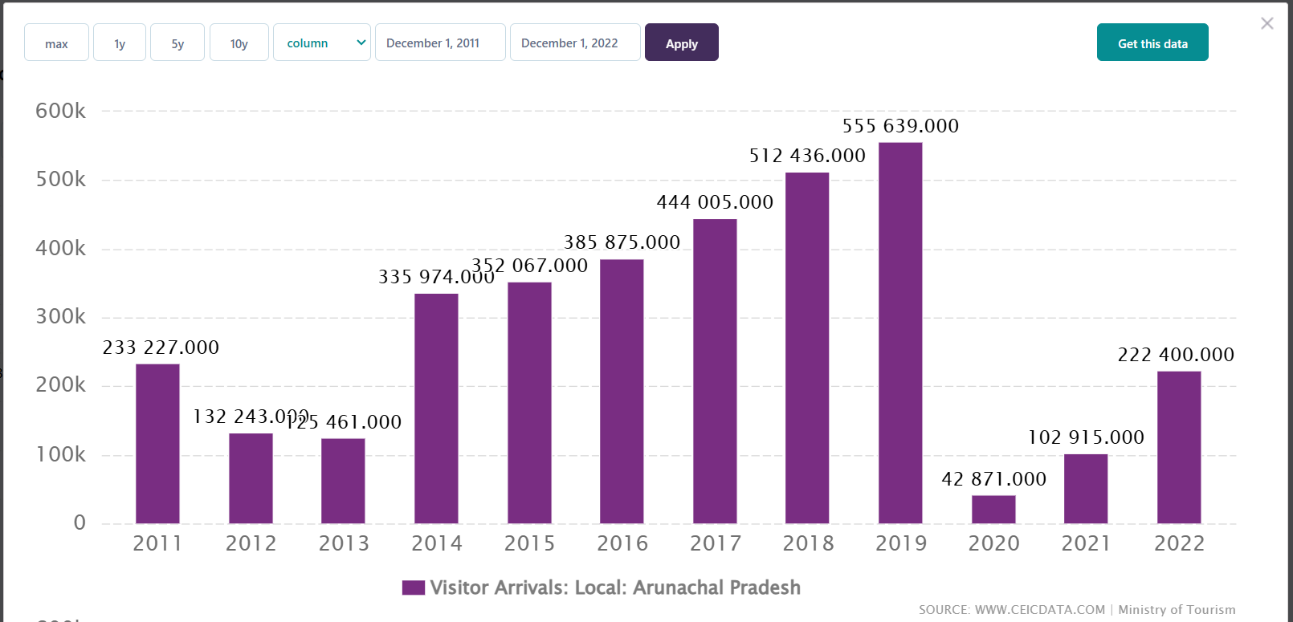

1. Mizoram 218,400

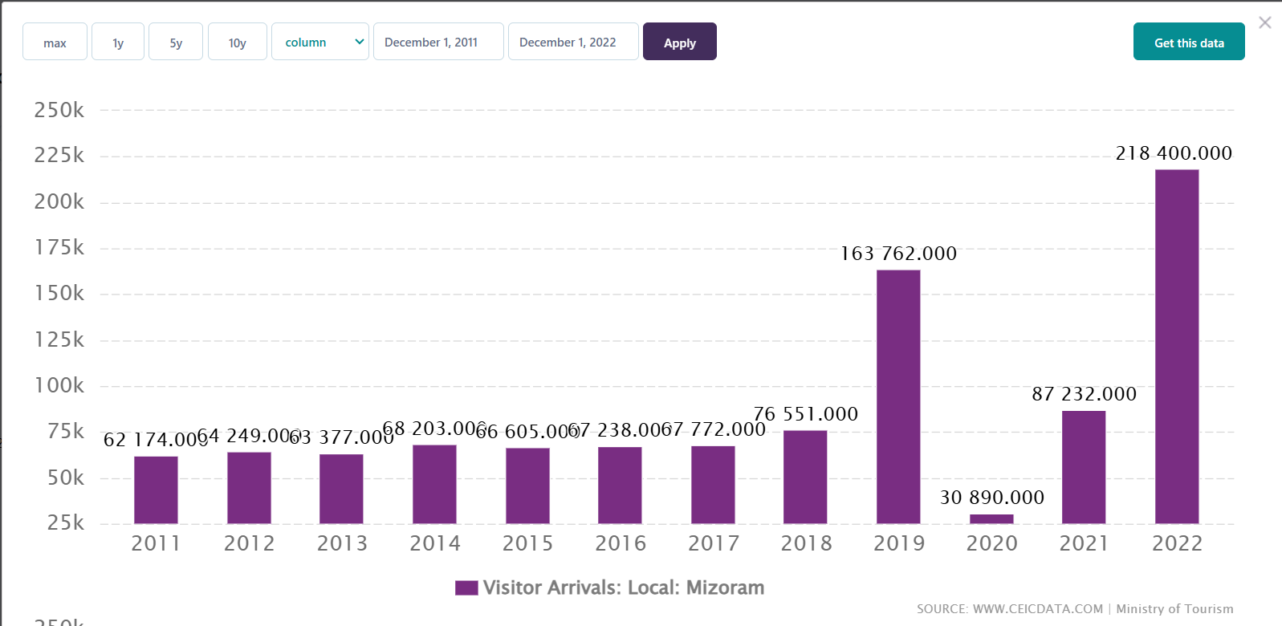

1. Manipur 139,500

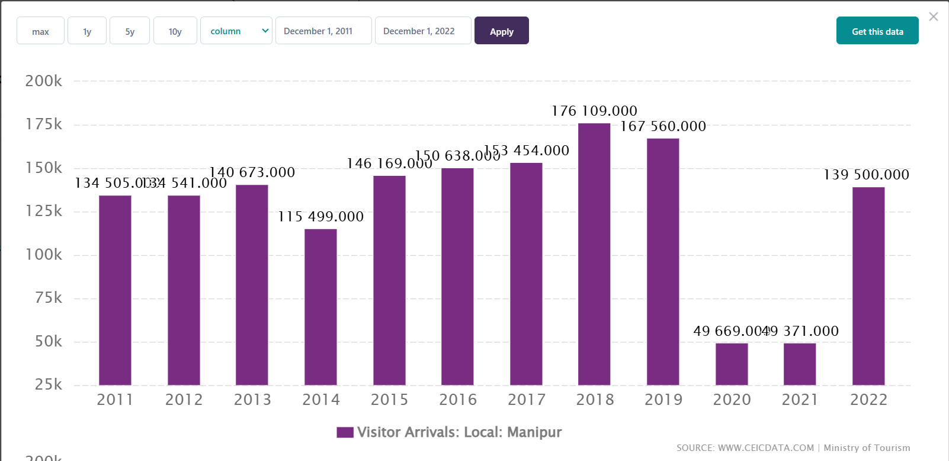

1. Nagaland 97,400

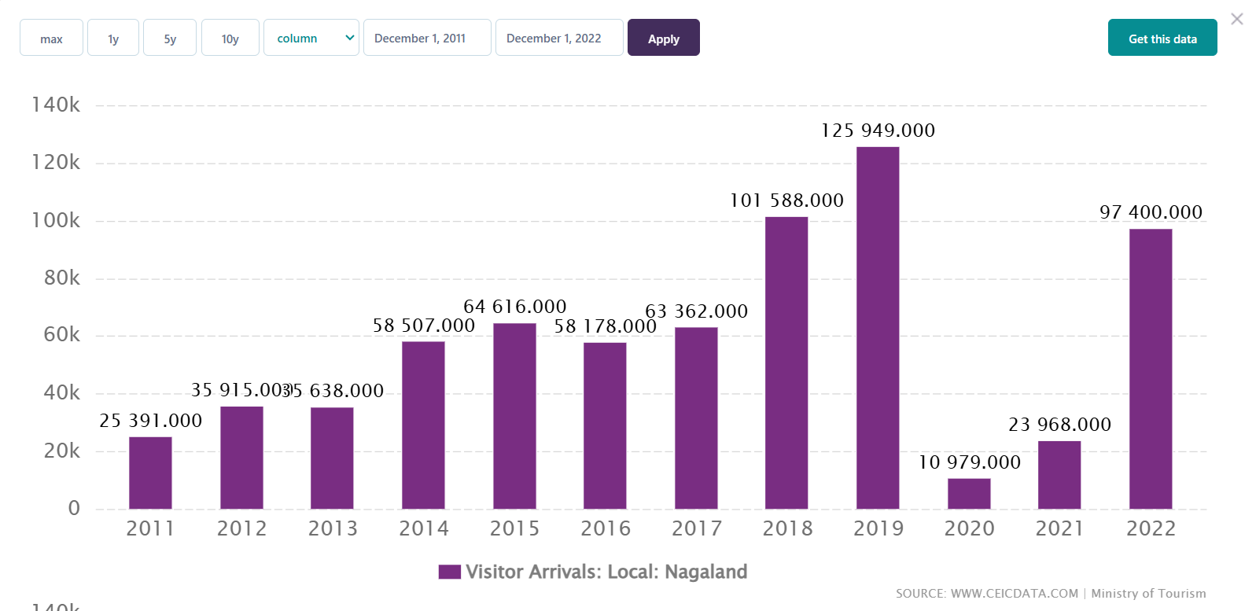

* **No of Hotels. (Competition)**

Source: https://tourism.gov.in/sites/default/files/2022-09/India%20Tourism%20Statistics%202022%20%28English%29.pdf

Total Capacity = No of rooms * 2

1. Arunachal Pradesh – 114
2. Assam – 1216
3. Manipur – 87
4. Meghalaya – 80
5. Mizoram – 66
6. Nagaland – 81
7. Tripura – No data

|  |  |  |  |  |  |  |  |
| --- | --- | --- | --- | --- | --- | --- | --- |
| **S. no.** | **State** | **No of Hotels** | **No of Tourists (2022)** | **No of rooms (2022)** | **Tourists (per day)** | **Accommodation Capacity (Per Day)** | **Tourists with no room (Probably)** |
| 1 | Arunachal Pradesh | 5000 | 83,82,000 | 114 | 22964.38 | 228 | 22736 |
| 3 | Manipur | 3000 | 2,35,000 | 87 | 643.8356 | 174 | 470 |
| 5 | Mizoram | 1000 | 2,18,400 | 66 | 598.3562 | 132 | 466 |
| 4 | Meghalaya | 2000 | 2,22,400 | 80 | 609.3151 | 160 | 449 |
| 6 | Nagaland | 1000 | 1,39,500 | 81 | 382.1918 | 162 | 220 |
| 2 | Assam | 25000 | 9,37,100 | 1216 | 2567.397 | 2432 | 135 |
| 7 | Tripura | 1000 | 97,400 | NA | 266.8493 | #VALUE! |  |

The climate is overall same throughout the North-Eastern States. As you can see, the demand and requirements for the rooms to be fulfil is most high in Arunachal Pradesh. The ratio of the no or tourists and the available rooms is very low. Roughly 22736 have no rooms per day in Arunachal Pradesh.

Therefore,

Among the northeastern states which are best to set up a hotel? – **Arunachal Pradesh**

1. **Customise the pivot charts to add/change the fields in the fields list with other fields and by using chart styles to customise the charts. (choose the data and parameters according to your choice)**
2. **Which is the best state for setting up a hotel? Why?**
3. **What is the average number of days the rainy season lasts in Indian states?**

June 1 and October 15

Average number of days the rainy season lasts: **177**

|  |  |  |  |  |  |  |  |  |  |  |  |  |  |  |
| --- | --- | --- | --- | --- | --- | --- | --- | --- | --- | --- | --- | --- | --- | --- |
| **YEAR** | **JAN** | **FEB** | **MAR** | **APR** | **MAY** | **JUN** | **JUL** | **AUG** | **SEP** | **OCT** | **NOV** | **DEC** | **Rainfall Month** | **No of Days** |
| 1991 | 14.3 | 28.1 | 27.8 | 51.7 | 68.9 | 184.7 | 279.2 | 268.1 | 140.7 | 61.8 | 30.2 | 14.7 | 7 | 210 |
| 1992 | 16 | 16.5 | 24.8 | 26.1 | 59.3 | 139.7 | 262.5 | 274 | 171.7 | 64.7 | 41.6 | 5.6 | 6 | 180 |
| 1993 | 18.2 | 25.6 | 41.6 | 27 | 71.3 | 172.1 | 305.4 | 203.2 | 208.5 | 87.9 | 30.5 | 16.5 | 6 | 180 |
| 1994 | 25 | 27.9 | 25.2 | 45.9 | 53.1 | 205.7 | 350 | 282.2 | 149.4 | 82.8 | 25.5 | 22.6 | 6 | 180 |
| 1995 | 31.3 | 29.4 | 28.3 | 32.4 | 82.4 | 143.3 | 323.4 | 269 | 179 | 78 | 36.8 | 9.2 | 6 | 180 |
| 1996 | 22.9 | 23.2 | 32.1 | 31.4 | 56 | 185.7 | 262.1 | 292.4 | 146.1 | 100.5 | 13.6 | 16.9 | 6 | 180 |
| 1997 | 14.3 | 10.4 | 30.3 | 46 | 48.6 | 171.7 | 281.5 | 261.9 | 151.4 | 61.1 | 57.6 | 48.3 | 6 | 180 |
| 1998 | 16.4 | 28.2 | 39.1 | 36.3 | 49.2 | 163.9 | 278.4 | 243.8 | 196.5 | 107.4 | 39.3 | 10.3 | 5 | 150 |
| 1999 | 13.7 | 11.2 | 8.8 | 19.3 | 94.9 | 169.9 | 261.7 | 213.2 | 183 | 117.2 | 20 | 3.7 | 6 | 180 |
| 2000 | 18.4 | 28.2 | 17.9 | 34.7 | 71.6 | 179 | 263.5 | 221.1 | 134.5 | 41.9 | 14.6 | 10 | 5 | 150 |
| 2001 | 6.7 | 11.6 | 19.9 | 44.6 | 62.9 | 221.2 | 281.1 | 205.5 | 111 | 100.4 | 19.7 | 16.1 | 6 | 180 |
| 2002 | 17.1 | 20.1 | 23.8 | 38.6 | 59.8 | 172.6 | 143.8 | 246.1 | 137.9 | 55.6 | 15.6 | 5 | 6 | 180 |
| 2003 | 7.3 | 42.3 | 36.7 | 36.6 | 40.1 | 169.3 | 306.5 | 243.6 | 183.4 | 92.7 | 11.5 | 17.2 | 5 | 150 |
| 2004 | 25.1 | 10 | 12.8 | 55.2 | 80.6 | 171.1 | 250.5 | 254 | 131.5 | 95 | 17.9 | 2.8 | 7 | 210 |
| 2005 | 28.1 | 41.8 | 42.5 | 37.7 | 46.1 | 143.2 | 334.1 | 190.1 | 206.9 | 99.3 | 27.2 | 11.2 | 5 | 150 |
| 2006 | 17.7 | 11.9 | 35.6 | 32.7 | 75 | 141.8 | 287.6 | 281.3 | 178.6 | 51.8 | 34.6 | 13.1 | 6 | 180 |
| 2007 | 1.7 | 36.7 | 35.2 | 30.6 | 46.8 | 192.5 | 286.2 | 257.4 | 206.8 | 55.7 | 14.4 | 15.3 | 5 | 150 |
| 2008 | 18.4 | 19.3 | 41.2 | 29.5 | 43.7 | 202 | 245 | 265.8 | 165.1 | 51.6 | 25.5 | 11 | 5 | 150 |
| 2009 | 12 | 12 | 14.2 | 25.1 | 56 | 85.7 | 280.7 | 192.5 | 139.4 | 71.4 | 53.7 | 11.1 | 7 | 210 |
| 2010 | 7.5 | 17 | 14 | 39 | 73.8 | 138.1 | 300.7 | 274.7 | 197.7 | 69 | 61.4 | 22.7 | 7 | 210 |
|  |  |  |  |  |  |  |  |  |  |  |  |  |  | 177 |